CareOS use case

About CareOS:

CareOS is a privacy-by-design, intuitive open platform that works naturally into your care, beauty, and health rituals. It makes the best possible use of the time you spend in front of a mirror to improve your well-being by organizing and enhancing information from any connected device, digital service, and CareOS’ own AI. By simply looking at and gesturing to the bathroom mirror, you gain access to all of the information you need to evaluate and improve your routines, experiment with your appearance, and learn about your health.

Challenge

Care-OS's smart mirror product integrated an AI model that can detect landmarks on the face with almost absolute precision, so it required a large training dataset with 99% accuracy.

CareOS did not have enough resources to develop a platform in house that allows 173 landmarks to be labeled on the face, while other open-source tools do not have the capabilities that CareOS required, so CareOS reached out to BlueEye for a solution to solve this issue.

CareOS AI’s team of 15 engineers could cover the entire labeling work, so the lack of labelers is also a huge challenge for the project.

Our solution (business)

BlueEye provided a customized solution that allows high-quality labeling of landmark points on the face. In addition, overall project review and progress tracking is also an important aspect for CareOS. BlueEye’s project management features provided our clients exactly what they were requesting. From project progress and data review, resource allocation, and issue tracking, customers can review and export data at any time to serve model testing.

BlueEye’s labeling teams that worked on the project were all trained thoroughly, with a clear QA process to ensure the training dataset reached 99% accuracy.

By the end of the project, BlueEye had labeled more than 10,000,000 landmark points with the help of AI assisted pre-annotation. More than 20 labelers involved were managed through individual quality control metrics and a strict review process.

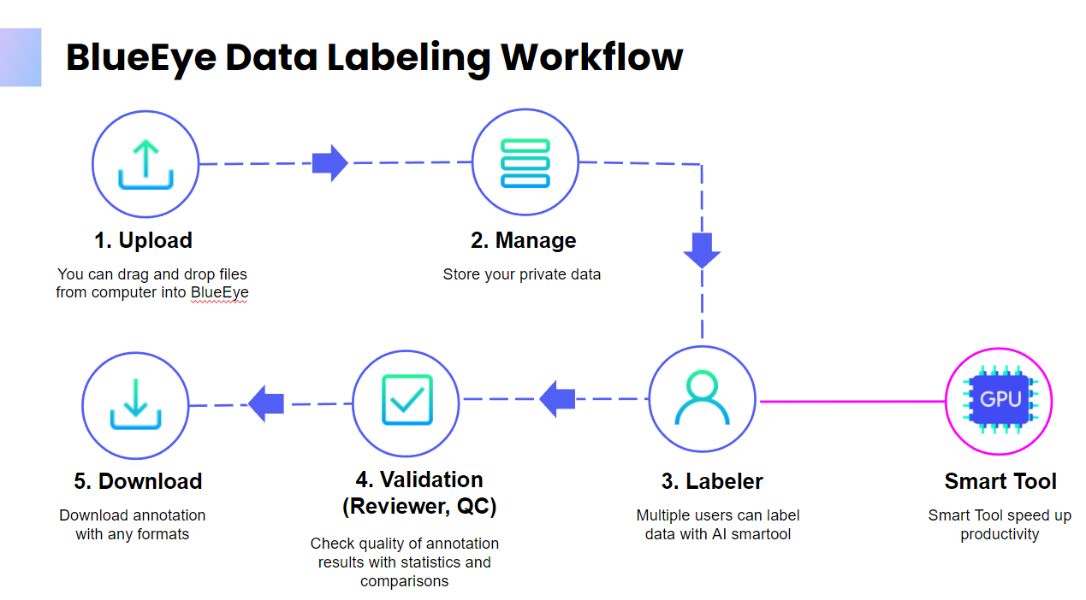

Our solution (Technical)

BlueEye’s Labeling platform has been specially equipped with a set of tools in order to meet CareOS’s high standard of facial landmark annotations. We first created helper utilities that targeted the trickiest parts of the face: the eyes’ iris. There are only 8 landmark points, but they are required to be laid on a perfect circle since the incorrect outcome will affect the final product’s quality dramatically. We customized the tool for that part so that the labelers only need to make just a few adjustments to create perfect annotations.

We also applied different image processing techniques, like auto-adjust white balance, contrast, and auto-extract contours, in order to enhance the visibility and correctness of every landmark point. Other utilities like auto-align landmark points, custom auto checking rules,... improved both productivity and quality at the same time.

After applying the tool, the labeling time per image dropped more than 80%, with much fewer reviews and corrections required. BlueEye is a web platform that allows customers to join and evaluate quality at any time, helping labeling projects to always achieve high efficiency and quality. The success of the project demonstrates how easy it is to modify and extend the BlueEye’s tools and features to meet the customers’ requirements and standards.

